# Technical Design Document: Programming_Exercise_3

# Name: Christian Innes
# Date: September 20, 2026
# Program Description: Gets total expenses along with the highest and lowest

##Function: num_expenses
Calls for the function to start taking in the expense information, gives the lowest expense, gives the highest expense, gives the total expenses.
## Parameters:
total gives the total expenses
Expense: represents the current expense
Highest: gives the highest expense
Lowest: Gives the lowest expense
##Variables:
mum_expenses: stores the number of expenses
expenses: stores the expense information
type: gives the type of expense
cost: gives the cost of expense
total_expenses: stores the total expenses
highest_expense: stores the lowest cost
lowest_expense: stores the lowest cost

##Logic:
Asks how many expenses they have
Takes the total number of expenses
Asks for the name and cost
Repeat until total expenses are reached
Displays the total costs
Display the highest expense
Display the lowest expense

##Return:
Gives the total cost of everything along with the highest and lowest expenses.

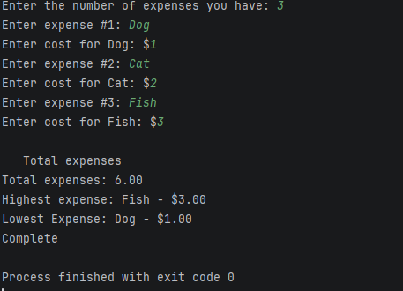

#Link to your repository: https://github.com/monky6676/COP2373

